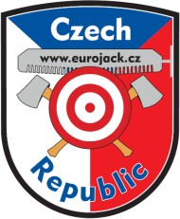

REGISTRATION FORM for
Eurojack European Championship 2/2022
Czech Republic – Jihlava 11. and 12. June 2022

One registration form has to be completed by each competitor (also valid for the current 10 best sportsmen of the Eurojack 2022 series!!!)

First name: | Last name:
Date of birth: | Address:
City/Town: | Zip code:
Country: | Telephone:
Email: | Profession:

Springboard with 2 boards: | RIGHT | LEFT
 | 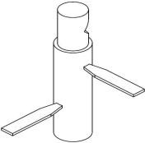 | 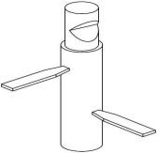

Participation in the CLIMBING (10 m) competition:
- ♀ Women competition (only up to the bell)
  - Saturday 11/6/2022 after the Eurojack Qualification
  - Sunday 12/6/2022 after the Eurojack Final
YES NO
- ♂ Men competition (up and down) – Saturday 11/6/2022 after the Eurojack Qualification
YES NO

Participation in the “JACK & JILL” competition on Saturday 11/6/2022 after the Eurojack Qualification:
YES NO
The “JACK & JILL” competition is limited to 10 couples.

I am only registering for the supplementary climbing competitions (not the Eurojack Qualification race and/or Final race):
YES NO

Sportsmen meeting, handing out of start numbers and wood numbers:
Saturday 11 June 2022 at 10:00 hrs. (competition starts at 12:00 hrs.)
Sunday 12 June 2022 at 09:30 hrs. (competition starts at 12:00 hrs.)

Automatic finalists, i.e. the current top 10 sportsmen registered for the Sunday final must report at the competition office on Saturday 11 June 2022 by 18:00 hrs. latest. Telephone nr. for the competition office is +420 777 657 299.

The Sunday final competition for men is for 18 participants. The Sunday final competition for women is for 3 participants.
The participation occurs to the international Eurojack regulations and at your own risk.

For further information (disciplines, detailed program, etc) see the program or watch news on www.eurojack.cz

In accordance with the Regulation (EU) 2016/679 of the European Parliament and of the Council on the protection of natural persons with regard to the processing of personal data and on the free movement of such data (General Data Protection Regulation - hereinafter referred to as the "GDPR" and Act No. 110/2019 Coll., on the processing of personal data, I hereby grant my consent to the processing of the above personal data for the purpose of keeping lists and records necessary to carry out activities related to the Eurojack race.
Furthermore, by signing this entry form, I give my consent to the possible use of photo and video documentation from the race in the media, on the Eurojack.cz website and on social networks.

Please send the filled in and signed registration form to: silova@eurojack.cz

Registration deadline is 27 May 2022!!!
Signature:

Disciplines for the Qualification (men + women) on Saturday 11.6.2022:
- Single Buck
- Flying discs (20)
- Underhand Chop
  - Men Ø 30cm
  - Women Ø 27cm

Disciplines for the Finals on Sunday 12.6.2022:

Men: Women:
- Underhand Chop - Underhand Chop (27cm Ø)
- Flying discs (20) - Flying discs (20)
- Single Buck - Single Buck
- Powe Saw - Axe Throwing
- Tree toping (10m)
- Springboard (2 boards)

